Prof. Ryan Clemmer P.Eng.

Interim Report: Medical Cart Redesign

Shahzaib Asher - 1000360

Matthew Spring - 1015469

Troy Campbell - 1019497

Mohammed Al Fakhr - 0982745

Executive Summary

Long-term care facilities are a vital to the smooth functioning of our society. COVID-19 has ravaged this industry and worsened a nursing shortage that was already causing harm to elderly Ontarians. Many elderly Ontarians who need care are for to wait for a spot in these facilities. This nursing shortage is caused by poor pay and poor working conditions. Nurses and other healthcare workers suffer from increased rates of musculoskeletal disorders that are developed due to the physical nature of their work. These disorders can be mitigated by allowing nurses to use tools with better ergonomic design. One of the tools nurses use most frequently is the medicine cart so any improvements to this cart would result in a better work experience for large parts of the day.

Together with input from the nurses at the Marshall Gowland Manor we have designed a new medical cart that improves the cart’s security, ergonomics and functionality. We have designed new security features like the rolling security door that protect against theft. We also designed a new system for pill storage and dispensing that should allow the nurses to work more efficiently. Adjustable handles were added to give the nurses a more comfortable user experience. Finally, we added an intuitive digital interface that controls all the cart’s systems. These features were chosen after several design iterations based on the criteria and constraints given to us by the nursing staff at Marshall Gowland Manor.

The rolling door uses a track system to slide over the pill compartment. This gives the pills a necessary second level of security. The pill storage system is able to store individual patient’s medications in a container that is unlocked when required by the nursing staff and locked when it is not required. The adjustable handle uses a threaded knob that can be loosened and tightened to adjust the height of the handlebar. Finally, the visual interface will be designed as an app using Android studio and will act as a means to retrieve patient information and control the cart mechanisms.

Contents

**List Of Tables** 3

1. Problem Statement 4

1.1.1 Problem Definition 4

1.1.2 Social Impacts 4

1.1.3 Health Impact 4

1.1.4 Safety Impacts 4

1.2 Objectives and Scope 4

2. Background 5

2.1 Literature Review 5

2.2 Constraints 6

2.3 Criteria 6

3. Methodology 7

3.1 Idea generation 7

3.2 Design Alternatives and Evaluation 7

3.2.1 Cart Handles 7

3.2.2 Cart security locking mechanism 8

3.2.3 Medication container mechanism 8

3.2.4 Control interface and hardware design alternatives 9

3.3 Design Evaluations 11

3.3.1 Cart Handles 18

3.3.2. Cart Security Mechanism evaluation 19

3.3.3 Medication container mechanism evaluation 20

3.3.4 Interface design evaluation 22

3.4 Selected Alternative 23

3.5 Selected Design Details 24

3.6 Project Milestones and Schedule 27

4. Conclusion 28

5. References 28

6. Appendix 31

6.1 Sensitivity Analysis 31

6.1.1 - Cart handle sensitivity analysis 31

6.1.2 - Cart security mechanism sensitivity analysis 31

6.1.3 - Cart medication container mechanism sensitivity analysis 32

6.1.4 - Cart interface application sensitivity analysis 32

6.2 Datasheets for electro-mechanical devices 32

6.3 Medical Cart Prototype Models 34

# **List Of Tables**

Table 1: Constraints table. 6

Table 2: Criteria table. 7

Table 3: Criterion matrix used for evaluating cart handle designs. 11

Table 4: Criterion matrix used for evaluating cart security mechanism designs. 13

Table 5: Criterion matrix used for evaluating pill container designs. 14

Table 6: Criterion matrix used for evaluating interface application designs. 16

Table 7: Comparison for alternative handle designs using weighted criterion matrix. 18

Table 8: Comparison for alternative security designs using weighted criterion matrix. 19

Table 9: Comparison for alternative pill container designs using weighted criterion matrix. 20

Table 10: Comparison for alternative interface designs using weighted criterion matrix. 22

Table 11: Power consumption breakdown for all electrical components. 25

Table 12: Item and cost breakdown estimation. 26

Table 13: Sensitivity analysis for cart handle criterion matrix. 31

Table 14: Sensitivity analysis for cart handle criterion matrix. 31

Table 15: Sensitivity analysis for cart pill container criterion matrix. 32

Table 16: Sensitivity analysis for interface criterion matrix. 32

# 1. Problem Statement

### 1.1.1 Problem Definition

Nurses at the Marshall Gowland Manor long-term care facility perform one of our society’s most essential jobs, taking care of the elderly. One of their most important tools is the medicine cart but these carts have several flaws that need to be addressed. The Marshall Gowland Manor management and nursing staff has provided criticism and feedback for these carts that will be used during the cart’s redesign. According to the nursing staff the carts have poor ergonomic design. The cart’s handle is set at a fixed height which causes problems for nurses of different statures. The cart’s weight and size also cause ergonomic and maneuverability problems which need to be addressed. The nurses find the carts to be heavy, bulky and difficult to store. The pill storage and dispensing system also needs to be reconfigured. The pill containers are difficult to dispense and refill which makes delivering medicine a needlessly tedious task. The nurses use a computer interface that is outdated and clunky to use. This interface needs to be more versatile and simpler to operate. The cart also lacks security features. Currently the cart has two main anti-theft components: its weight and a drawer locking mechanism. The cart’s security could be vastly improved with more security features.

### 1.1.2 Social Impacts

Long-term care facilities were struggling to hire and retain nurses before COVID-19 and are in a much more dire situation now as nurses leave due to low pay and poor working conditions [1]. Currently there is not enough space in long-term care facilities, which has resulted in nearly 40,000 Ontarians to be left waiting for a spot [1]. The Ontario government has directed 2.6 billion dollars to deal with this situation, but today many facilities remain understaffed [1]. Better medicine carts will not solve the long-term care nursing crisis but any small improvements to the working conditions of this job can help.

### 1.1.3 Health Impact

The nurses use a medicine cart for many of their daily tasks and many of these tasks can become physically straining with poor ergonomic design. Due to the challenging tasks nurses are required to perform they are more likely to develop musculoskeletal disorders [2]. Nurses and other health care workers had the fifth highest number of musculoskeletal disorders in the US [2]. Better ergonomics can help to reduce the number of people suffering from musculoskeletal disorders. Finding ways, small or large, to relieve our long-term care nurses of physical strain should help with their physical wellbeing.

### 1.1.4 Safety Impacts

The medicines that are carried by these medical carts can be dangerous when taken without a professional's supervision. They are also valuable and as a result theft of these medicines is a major concern. When medicines are stolen it puts the residents of a long-term care facility at risk due to revenue loss, legal consequences, and infected patients [3]. Improved security in medicine carts should result in a reduction in these negative effects which will improve the safety of residents and long-term care facilities.

## 1.2 Objectives and Scope

The goal of this project is not to completely reengineer the long-term care facilities medicine cart. The core of the medicine cart does not need to be redesigned. The new design only needs to make minor changes to the individual components of the cart based on feedback from the nursing staff at Marshall Gowland Manor. Our objective is to design a medicine cart that allows the nursing staff at Marshall Gowland Manor to perform their daily duties in the most effective way possible. To accomplish this, we must improve the functionality, ergonomics, and security of the carts. This will allow the nurses to work quicker and in a more comfortable manner. The cart must be as functional as possible, the cart will retain all its core features and more features can be added to improve the cart's effectiveness. The cart must be maneuverable. The nurses have trouble steering the cart in tight spaces which puts unnecessary strain on their bodies, better maneuverability will greatly reduce this strain. The cart must be durable. Medicine carts are subjected to many bumps and crashes throughout the day, a durable design means the cart will not break down when it is most needed. The carts’ security is of the utmost importance. These carts contain medicine that has been the target of theft so better security systems should be able to deter this crime. Lastly, the carts must be very user friendly. Medical carts get a lot of use throughout a nursing day and an unintuitive design could severely impact a nurse's workflow and overall effectiveness. This report will deal with the design process and design selection of a new medical cart. The prototype development will not be addressed in this document.

# 2. Background

## 2.1 Literature Review

Administering medicines to residents at a long-term care home is a crucial part of a nurse’s job. There are many dangers associated with incorrect procedures in organizing and administering drugs. At healthcare facilities, 56% of preventable adverse medication reactions occur at the ordering and organization stage and 34% of preventable adverse medication reactions occur at the administering stage [4]. These factors account for the majority of all preventable adverse effects from medicines and warrant an investigation into solutions to these issues.

Reducing the negative impacts of medication administration begins at the organizational level, with organizing the purchasing, storing, and transportation of medicines. This stage involves several parties including pharmacies, healthcare facilities, nurses, and patients/residents. The gap between each of these stages introduces potential broken links in the process which can cause errors in medication administration [3]. With the help of a medical facility organizational software, these gaps can be bridged and errors reduced. Keeping track of medicines will also help reduce the impacts of theft by increasing overall security throughout the supply chain.

The last stage before medicines reach residents is the administration by nurses, who interact with residents directly on a regular basis. The tools and equipment that nurses’ use for their daily jobs in a long-term care facility has an impact on their ability to complete tasks in an efficient and effective manner. At the Quebec University Hospital Center, 80% of the nurses agreed that medical carts play a crucial role in their jobs and 64% thought there could be improvements made to their overall process to reduce medication related incidents [5]. The most basic aspects of the improved cart design would include upgraded ergonomics, this is a lacking feature which could potentially reduce nurse’s workplace injuries by 21% [6]. These carts are loaded with heavy equipment and materials which are cumbersome to deal with for up to 12 hours a day as some nurses often do. According to an interview with Jane Joris, the general manager of Lambton Cares Group, the medical carts which are currently in use are from the Avalo series of medicine carts by Capsa Healthcare [7].

While these carts are robust in construction, they are missing features as simple as handlebars on several of their models, and do not have any adjustable features to accommodate individuals of varying heights. Implementing these essential ergonomic features, as well as other quality of life improvements for nurses will help them be more effective and efficient in their jobs.

## 2.2 Constraints

Table 1: Constraints table.

|  |  |  |
| --- | --- | --- |
| **Constraint** | **Description** | **Impact and Significance** |
| Must be compatible with medications | Must be able to fit medications of various quantities and form factors including pills, syringes, bottles, etc. | This is mandatory for nurses to be able to securely transport all kinds of medication and equipment required for their residents |
| Must have an ergonomic design | Interactive points on the cart must be ergonomically designed to provide ease of use for nurses | Nurses handing the cart all day long should not suffer any ergonomics related injuries, all features must be comfortable to use and handle for extended periods of time |
| Must require minimal force to maneuver cart | Cart should roll freely when unlocked, and maneuver easily by anyone over long periods of time | Cart must roll smoothly to prevent strain in nurses who must move it long distances throughout the day |
| Weight must be substantial so that it may not be easily stolen | Must be substantially heavy so that it cannot be simply picked up and carried away | A built-in security feature of the cart must be that it weighs a substantial amount, enough to deter thieves from simply carrying it off the premises |
| Must have multiple security measures | Must have basic security measures for all contents, and include extra security measures for narcotics | Single security is required to secure all over the counter medicine and equipment from theft, and double security is required for all restricted drugs |
| Must meet specific standards and regulations | Standards and regulations include Canadian Electrical Code, Professional Engineering of Ontario, ISO-14001 and ISO-9001 | This is required for the final design of the cart to be able to put it use at a long-term care home |

## 2.3 Criteria

Table 2: Criteria table.

|  |  |  |
| --- | --- | --- |
| **Criterion** | **Description** | **Impact and Significance** |
| Maximize storage capacity | Organize space effectively to be able to store as many supplies as possible | Storing and transporting supplies is the main function of the cart, and the priority should be to allow as many supplies as possible to be loaded at once |
| Maximize ease of use | Simplify operation of cart and database app to be intuitive and easy to use | Nurses with different experience levels should all be able to have a seamless experience, there should be minimal complexity in operating the physical and digital features |
| Maximize cart ergonomics | Implement as many ergonomic features as possible for all interactive areas | Reduce the physical strain on nurses who use the cart for extended periods of time, design features to be comfortable over extended periods of time |
| Minimize cost | Reduce the cost of the cart as much as possible by reducing unnecessary features | Use cost effective materials and parts to provide the best value for the cart, this will allow the cart to be widely available to a range of purchasing budgets |
| Minimize energy usage | Use low power components to minimize electricity running costs, and in turn maximize battery life | Select low power components with low energy usage to extend the battery life of the cart as long as possible and reduce charging downtime |
| Minimize maintenance | Design simple mechanisms to make the cart reliable and require minimum upkeep and maintenance | Use simple mechanisms and components that are not expensive to maintain or replace, this will reduce repair downtime and increase the lifespan of the cart |

# 3. Methodology

## 3.1 Idea generation

After defining the constraints and criteria and having multiple meetings with in-industry nurses to conduct important information regarding the idea generation, the team started using different brainstorming techniques to develop new ideas. The main brainstorming technique that was used is the 6-3-5 method. Every member was asked to come up with three different ideas. These ideas were then presented in the weekly meeting. The result was a combination of different design ideas that best met the chosen constraints and criteria.

## 3.2 Design Alternatives and Evaluation

### 3.2.1 Cart Handles

Improving the ergonomics of the medication cart is one of the primary goals of this project, one of the ways we will accomplish that is by adding an adjustable handle. Pushing and pulling heavy loads with the cart handle at a non-optimal height can cause undue strain on a nurse’s body. Allowing the nurses to adjust the cart handles to a more comfortable position should help negate this strain. Nurses use these carts for large parts of their day so its ergonomic design is of the utmost importance to their wellbeing. The handles must also be strong and rigid enough to push the medical cart and support the weight of an individual leaning on them.

#### 3.2.1.1 Motorized Adjustable Handles

Using a motorized system for adjusting the vertical height of the cart handles would provide the best user experience to the nurses. This would allow nurses to interact with buttons that raise and lower the cart’s handles to their preferred height. The mechanism for this feature would have a rack and pinion driven by a servo motor controlled by physical buttons, or a digital interface (See appendix A).

#### 3.2.1.2 Manually Adjustable Handles

Having a manually adjustable setup for the cart would be the most cost-effective option for the handles. This would allow users adjust the handle height by loosening and tightening a threaded knob connected to the handles (See Appendix A). This mechanism would be very reliable with no mechanical parts that are at risk of failing.

### 3.2.2 Cart security locking mechanism

Unfortunately, the medicines stored in these medical carts are known to be stolen by thieves and drug abusers. Therefore, the security of the cart is one of the most important factors in the cart's design. The security features of the cart must be effective at deterring and stopping potential thieves but cannot intrude on the nurses’ effectiveness. These features must also be cost effective and reliable.

#### 3.2.2.1 Pin locks

The first potential security mechanism is a pin lock that uses a solenoid per container row to slide through a designated slot in the box to restrict access when the nurses are not dispensing medication. The box will have a circular slot at the bottom allowing the solenoid to slide through the row and lock the whole row.

#### 3.2.2.2 Magnetic locks

The second potential design idea is to use magnetic locks. The box will have a cut out to hold a magnet and when the box is put in place a circuit will trigger the magnet causing the box to be held securely. This design will use a lot of energy and cannot function if the power is out. Which causes a safety and security hazard.

#### 3.2.2.3 Rolling safety door

The third potential design is using a rolling safety door that slides over the pill containers and can be locked manually or automatically if needed. The roller will be attached on top of the dispensing tray and when activated the sheet rolls over top of the containers on rails securing the medication as the second lock mechanism.

### 3.2.3 Medication container mechanism

The medicine storage containers are at the core of the medicine cart. Nurses need to be able to easily access the medicines and distribute them efficiently. The containers must also be very secure in order to prevent the medicines from being stolen. Large numbers of pills need to be stored for each resident, so storage space is also a major concern. Finally, cost plays an important factor in this design. Lower costs will allow the long-term care facilities to spend more of their budget on other important medical technologies.

#### 3.2.3.1 Vertical drawers.

The first potential design was having vertical drawers and storing singular pills in each compartment.

This design was built on the idea of having the medical cart store medications for weekly use instead of needing to refill it every day. When the nurse scans the patient’s barcode a list of medication is displayed on a tablet attached to the cart with information about the medications. Then the vertical drawer’s open giving the nurse access to secondary drawers that contain the pills. After the nurse takes the required pills, the vertical drawers go down and lock the compartments so there is no access to them unless the nurse scans the patient’s barcode.

#### 3.2.3.2 Pill by pill dispensing

The second potential design for medication dispensing is using pill by pill dispensing method. This design uses a spring mechanism to dispense singular pills. First when the nurses scans the patient code the system then sends the number of pills to be dispensed. This design will require multiple storing and dispensing mechanisms on the cart which will increase the cost drastically. When the pills get dispensed, they will be sent to a sanitized compartment where the nurse can access them. This mechanism will only dispense pills and no other types of medications.

#### 3.2.3.3 Top access compartments.

The third potential design was created after a meeting with a nurse, she talked about the medications used and how it’s distributed. They use boxes to store all medication types from pills to vials. Therefore, the design created was shaped around the idea of storing the medication into boxes that uses a mechanical mechanism when placed and cannot be accessed unless the box is raised from the compartments using a servo motor. The box raises when the nurse scans the barcode. The servo motors have a rod (cam mechanism) which raises the box when a signal is received.

### 3.2.4 Control interface and hardware design alternatives

With all the aforementioned security and automation features that will be implemented into the redesigned medicine cart there will need to be a way to allow the user to easily control these features. One of the components the team has agreed to implement for the cart redesign is a visual interface that the user can interact with. This interface will be fixed to the medicine cart and will allow the user to control the locking/unlocking mechanism used for the wheels of the cart, the mechanism used for locking individual resident medication containers and control over the security door for the restricted medications.

A digital interface was necessity to allow the users to control these mechanisms. However, during the team’s correspondence with professionals in the industry like Jane Joris, general manager of the Lambton Cares Group of long-term care homes, it was found that additional features such as patient records and direct access to pharmacy databases through the interface were commonly requested features by nurses in the industry.

After continued correspondence with Jane Joris the team decided on the following list of features the interface will implement:

* Inventory management: allowing the user to check the supply of medications and equipment on the cart as well as modifying quantities, allowing the user to accurately keep track of consumed supplies.
* Resident and medicine data retrieval: the ability to add and retrieve resident records from a database the application is synchronized to. This includes information such as a list of medications and equipment.
* Medicine dispensary: allowing the user the ability to choose and load patient’s medications into locked containers on the cart and dispense the medication as needed. Schedules can also be created to save patient container information.
* Requisitions: the ability to create requisitions on supplies that are depleted from the cart. These requisitions can be sent from the cart pending approval by a manager before being sent to the designated suppliers.
* Inventory tolerance: tolerances can be put on certain medications/supplies so that when the quantity of these items reaches the tolerance level that item is automatically added to a draft requisition form. This requisition will be sent out at the end of the day.
* Mechanism controls: the user will be given access to the wheel locking mechanism and individual pill containers when needed.

With the features of the interface determined the team produced a few approaches on how the interface was going to be implemented. The following criterion matrix is used to evaluate the designs.

#### 3.2.4.1 Touchscreen interface compatible with a Raspberry Pi microcontroller

The team’s first potential idea for an interface was to simply purchase a touchscreen that could be connected to a microcontroller such as a Raspberry Pi. From there the application would be developed right on the Raspberry Pi through a programming language such as JavaScript or Python. Communication from the touchscreen to the microcontroller would be seamless and simple due to its direct connection and native compatibility which would result in easy information exchange between the devices. The same Raspberry Pi would be used to control the locking mechanisms found on the medical cart, allowing the interface code and the locking mechanism controls to be made into one application that will run on the Raspberry Pi.

#### 3.2.4.2 Developing the interface as an app using Android Studio

The second potential idea involved creating the interface as an android application using an integrated development environment such as Android Studio. The user can use the application on any Android device and will have access to all features and mechanism controls. However, the app itself will be designed to act only as the visual interface to the user, the functionality of the locking mechanisms and data retrieval will be accessed on two separate devices. To control the various locking mechanisms found on the cart a microcontroller will still be required. Because of this a separate section of code must run on the microprocessor and be able to intercept commands sent from the android application (commands will be sent either through a wired serial port connection or over Wi-Fi using HTTP requests) and correctly move the mechanism to reach the desired state. The android application will also communicate with a local server using HTTP requests to call RestApi routes that will return the data requested by the user. A SQL database will be used to store information such as resident records and medications, the server will interact with this database to both store and retrieve records.

#### 3.2.4.3 Developing the interface as a progressive web application (PWA)

The final idea for the interface was to develop it as a progressive web application, this idea has similar traits to the idea of developing the interface with some notable differences. A progressive web application is developed to be delivered through web browsers such as google chrome and because of this will make the application available on most mobile devices. If the progressive web application meets a certain criteria, it can be installed on any mobile device and functions exactly like an app. The PWA will function only as a visual interface and like the previous design alternative will rely on a microcontroller to handle mechanism controls and a local server to handle data storage/retrieval. The main appeal of this alternative is to design an application that will be accessible through a web browser to make it compatible with any mobile device. Once downloaded a PWA functions identically to an app.

## 3.3 Design Evaluations

Table 3: Criterion matrix used for evaluating cart handle designs.

|  |  |  |  |  |  |
| --- | --- | --- | --- | --- | --- |
| Scale | | Criteria Metric | | |  |
| Level | Value | Ease of Use | Reliability | Strength | Cost |
| Perfect | 5 | The handles are extremely simple to operate and requires very little user action. | The mechanism has no parts that are liable to fail during the cart’s lifespan. The mechanism will work for the cart’s entire lifetime barring extreme circumstances. | The handles are extremely sturdy. They can support loads that far exceed the expected load ranges. | The cost to manufacture the handle is minimal (0-20% of average) compared to the alternatives. |
| Very Good | 4 | The handles are very simple to operate and requires some user action. | The mechanism has one or two parts that are liable to fail during the cart’s lifespan but can be easily replaced. The mechanism is very likely to work for the cart’s entire lifetime. | The handles are very sturdy. The handles can support loads that exceed the expected load ranges | The cost to manufacture the handle is low (21% to 50%) compared to the alternatives. |
| Satisfactory | 3 | The handles are simple to operate but requires the user to expend some effort to change the handle’s height. | The mechanism has a few parts that could require replacement during the cart’s lifespan. These parts should be easily replaceable. | The handles are somewhat sturdy. The handles can support loads that barely exceed the expected load ranges | The cost to manufacture the handle is low to average (51% to 100%) compared to the alternatives. |
| Subpar | 2 | The handles are unintuitive and requires significant effort to change the handle’s height. | The mechanism has a few parts that will require replacement during the cart’s lifespan. These parts may be difficult to replace. | The handles feel somewhat weak. The handles can only support loads that are within expected load ranges | The cost to manufacture the handle is high (101% to 200%) compared to the alternatives. |
| Extremely Ineffective | 1 | The handles are very complicated but requires unreasonable effort to change the handles height. | The mechanism has several components that will need replacements throughout the cart’s lifetime, These parts will be difficult to replace. | The handles cannot support loads in the expected load ranges. | The cost to manufacture the handle is very high (200%+) compared to the alternatives. |

Table 4: Criterion matrix used for evaluating cart security mechanism designs.

|  |  |  |  |  |  |
| --- | --- | --- | --- | --- | --- |
| Scale | | Criteria Metric | | |  |
| Level | Value | Maintenance & Reliability | Accessibility | Security | Cost |
| Perfect | 5 | The security mechanism must have a very slight chance of breaking down. It must be very easy to repair or replace broken parts that do fail. | The security mechanism does not impact the ease of access to the medicines. | The security mechanism is very effective. Bypassing this security measure would take a lot of time, skill or specialized tools. | The cost to manufacture the handle is minimal (0-20% of average) compared to the alternatives. |
| Very Good | 4 | The security mechanism must have a low chance of breaking down. It still must be easy to repair or replace broken parts that do fail. | The security mechanism slightly reduces the ease of access to the medicines. | The security mechanism. Bypassing this security measure would take some time, skill or tools. | The cost to manufacture the handle is low (21% to 50%) compared to the alternatives. |
| Satisfactory | 3 | The security mechanism may breakdown during its lifetime. Repairing or replacing broken parts is still a simple process. | The security mechanism makes accessing the medicines noticeably more difficult. | The security mechanism is effective against some attacks but weak against others. This security measure can be bypassed with brute force or some other simple yet time consuming method. | The cost to manufacture the handle is low to average (51% to 100%) compared to the alternatives. |
| Subpar | 2 | The security mechanism is expected to breakdown during its lifetime. It may be difficult to repair or replace broken parts that do fail. | The security mechanism makes accessing the medicines significantly more difficult. | The security mechanism is not very effective but does provide enough of a deterrent to stop most ordinary thieves. | The cost to manufacture the handle is high (101% to 200%) compared to the alternatives. |
| Extremely Ineffective | 1 | The security mechanism experiences frequent breakdowns. It is difficult to repair or replace broken parts that do fail. | Accessing the medicines is very time consuming ad difficult. | The security mechanism is not effective and is easy to bypass with simple tools and little knowledge or skill. | The cost to manufacture the handle is very high (200%+) compared to the alternatives. |

Table 5: Criterion matrix used for evaluating pill container designs.

|  |  |  |  |  |  |
| --- | --- | --- | --- | --- | --- |
| Scale | | Criteria Metric | | |  |
| Level | Value | Maintenance & Reliability | Workflow | Storage | Cost |
| Perfect | 5 | The container mechanism must have a very slight chance of breaking down. It must be very easy to repair or replace broken parts that do fail. | The pills and pill boxes are very quick and easy to access. Accessing and distributing the pills requires as few steps as possible. | Allows the user to store significantly more pills and pill boxes than average (200%+) | The cost to manufacture the handle is minimal (0-20% of average) compared to the alternatives. |
| Very Good | 4 | The container mechanism must have a low chance of breaking down. It still must be easy to repair or replace broken parts that do fail. | The pills and pill boxes are quick and easy to access. Accessing and distributing the pills requires one or two more steps than level 5 but does not significantly hamper workflow. | Allows the user to store more pills and pill boxes than average (151%-200%) | The cost to manufacture the handle is low (21% to 50%) compared to the alternatives. |
| Satisfactory | 3 | The container mechanism may breakdown during its lifetime. Repairing or replacing broken parts is still a simple process. | The pills and pill boxes are somewhat quick and easy to access. Accessing and distributing the pills results in a noticeable reduction in workflow. | Allows the user to store slightly more than the average amount of pills and pill boxes (101%-150%) | The cost to manufacture the handle is low to average (51% to 100%) compared to the alternatives. |
| Subpar | 2 | The container mechanism is expected to breakdown during the cart’s lifetime. It may be difficult to repair or replace broken parts that do fail. | The pills and pill boxes are somewhat difficult to access. Accessing and distributing the pills results in a noticeable and harmful reduction in workflow. | Allows the user to store slightly less than average amount of pills and pill boxes (50%-100%) | The cost to manufacture the handle is high (101% to 200%) compared to the alternatives. |
| Extremely Ineffective | 1 | The container mechanism experiences frequent breakdowns. It is difficult to repair or replace broken parts that do fail. | Accessing the medicines is challenging, time consuming or poses an ergonomic risk. | Allows the user to store much less than average amount of pills and pill boxes (50%-) | The cost to manufacture the handle is very high (200%+) compared to the alternatives. |

Table 6: Criterion matrix used for evaluating interface application designs.

|  |  |  |  |  |  |
| --- | --- | --- | --- | --- | --- |
| Scale | | Criteria Metric | | |  |
| Level | Value | Testing & Feedback | Accessibility & Compatibility | Integrated development environment (IDE) support. | Cost |
| Perfect | 5 | Testing the application on its respected platform is fast and very simple allowing for rapid feedback on implementation. | The interface application can effortlessly be accessed on other devices using the same platform, but also can be accessed by devices on other platforms. | The IDE used can assist in the development process greatly through its environment setup, development tasks and relevant developer tools. Tools which help greatly reduce tedious aspects of development. | The cost of maintenance on the application is inexpensive. Additionally, the cost of the devices used in creating an interface application is at a realistic price point where mass manufacturing is possible. |
| Very Good | 4 | The platform has a testing environment that is quite quick and simplistic allowing for continuous feedback on the applications implementation. | The interface application can be accessed on other devices using the same platform quite easily. However, devices on different platforms cannot access the interface application. | The IDE used provides solid support for developing the application. Where most of the tools it supplies directly help in developing the application for the interface. | Maintaining the interface application requires some expense, however the devices used are still relatively inexpensive for mass manufacturing. |
| Satisfactory | 3 | Testing using the respected platform is of the expected standard and is simple enough. allowing for enough feedback when testing the application implementation. | The platform used for developing the interface application is incapable of being accessed on other platforms. Accessing on the same platform is possible but may require instructions for the user. | The selected IDE provides the essentials to the user such as environment setup. Some of the developer tools provided are helpful for developing the application and help cut down on time. | Maintenance of the application is still a low expense. However, the devices used are expensive enough that units cannot be built in mass. Manufacturing is still possible however quantity will be limited. |
| Subpar | 2 | Developing on the respected platform makes testing a little difficult and slows down the feedback needed on the implementation of the application. | Devices on different platforms than the original can’t access the interface. Accessing the interface on the same platform would require instructions and assistance from developers. | The IDE provides the essential services to the user. However, the IDE is too general to provide specified tools that would help in the development of an interface application | The expense of maintaining the interface application will be based on the number of units built. Due to the high price of the devices needed for the application to run the quantity of units will be heavily limited. |
| Extremely Ineffective | 1 | Using the respected platform for testing ensures the rate of feedback will be too slow to make meaningful progress. | The interface application is not available on any device besides the device it was developed on. | The IDE used provides no real services to the user and does not provide any features or tools that would help the user in any way. The IDE is considered a hinderance to the development process. | The cost of maintaining the application will depend on the number of units. The price of the individual devices is expensive enough that the prototype will be the only model built. |

### 

### 3.3.1 Cart Handles

Table 7: Comparison for alternative handle designs using weighted criterion matrix.

|  |  |  |  |  |  |  |  |
| --- | --- | --- | --- | --- | --- | --- | --- |
| Criterion | Weight  (%) |  | Automatically Adjustable Handles | |  | Manually Adjustable Handles | |
|  |  |  | Score | Weighted |  | Score | Weighted |
| Ease of Use | 30 |  | 5 | 1.5 |  | 3 | 0.9 |
| Reliability | 30 |  | 2 | 0.6 |  | 4 | 1.2 |
| Strength | 20 |  | 3 | 0.6 |  | 4 | 0.8 |
| Cost | 20 |  | 1 | 0.2 |  | 5 | 1 |
| Total: |  |  |  | 2.9 |  |  | 3.9 |

With a criterion matrix established the designs for the cart handles can be evaluated to get a sense of the preferred design. A score will be given to each design in the criterion matrix and a weight will be applied, weighted scores will be added from each design and the total will determine the preferred design.

The weightings are established based on what the team found most valuable for a cart handle. The two largest factors the team deemed important were ease of use and reliability. These factors were given a weight of 30% because most of the interaction a user has with the cart will involve pushing and pulling. Therefore, making handles that are reliable and easy to use is great concern in handle designs. Strength and cost were given a weight of 20%. However, are still important factors. The user will exert a good amount of force on the handle to move the cart and a good handle design must be able withstand that without breaking the mechanism holding the handle in place. The cost of the handle design must also be reasonable to provide a cost effective product to the customer.

The lowest scoring design was the automated adjustable handles. Using a visual interface to set up a preferred height on a user-by-user basis would make the handles fully automated, and in doing so would make using the handles effortless on the user's part. However, there is a risk of reliability using mechanical devices to consistently raise the handles to the correct height without error. Additionally, the cost of implementing an automated handle system would significantly increase the prototype bill.

The design that ranked higher on the criterion matrix was the manual adjusted handles. While this design requires more effort on the user’s part than the previous design there are many factors that made this design more appealing. One of the largest factors was the cost. Comparatively this design would be cheaper and simpler to implement onto the cart. The other components relative costs meant keeping the handle design cheap was a top priority. Additionally, a manual design is more reliable as the mechanism is quite simple and does not require any electromechanical components.

To ensure the best option was selected a sensitivity analysis was performed on the handle criterion matrix. The weights were adjusted to be the following: 20, 10, 40, and 30 for ease of use, reliability, strength, and cost, respectively (Refer to appendix A for sensitivity analysis table). Evaluating the designs under this criterion ensures the design with the best strength and cost would be chosen as the preferred design. The following scores were produced under this criterion: 2.7 for the automatic handles and 4.1 for the mechanical handles. Evaluating the designs under a strength-cost criterion the manual handle design is favored over the automated handle design.

### 3.3.2. Cart Security Mechanism evaluation

Table 8: Comparison for alternative security designs using weighted criterion matrix.

|  |  |  |  |  |  |  |  |  |  |  |
| --- | --- | --- | --- | --- | --- | --- | --- | --- | --- | --- |
| Criterion | Weight  (%) |  | Pin locks | |  | Magnetic locks | |  | Rolling safety door | |
|  |  |  | Score | Weighted |  | Score | Weighted |  | Score | Weighted |
| Maintenance & Reliability | 40 |  | 4 | 1.6 |  | 2 | 0.8 |  | 5 | 2 |
| Accessibility | 20 |  | 4 | 0.8 |  | 2 | 0.4 |  | 4 | 0.8 |
| Security | 30 |  | 5 | 1.5 |  | 3 | 0.9 |  | 5 | 1.5 |
| Cost | 10 |  | 1 | 0.1 |  | 1 | 0.1 |  | 3 | 0.3 |
| Total: |  |  |  | 4 |  |  | 2.2 |  |  | 4.6 |

The potential medications security lock designs were evaluated using weighted scores for each criterion. These scores were added up and the design with the highest total score was selected as the desired implementation for the interface application.

The weights for the criterion matrix reflected what the team found most valuable for the design. The most important factors that the team selected were maintenance and security. The medication in the carts are valuable and requires good security design to reduce rates of theft. Accessibility was weighted at 20% due to the importance of having easy access to the pills and pill containers. This will allow for the quick handling of medication. The cost had the lowest weighting, because safety and security of the medication is very important, and theft of medication could end up costing the long-term care facility much more in legal fees and resupply costs.

The lowest scoring design was the magnetic locks. It had a higher maintenance frequency than the other designs which lowered its score significantly. The security system is also not functional if there is no power. Also, the magnetic field can affect the other medical equipment that is stored on the cart. This caused low scores security and accessibility. The magnetic locks will be fairly expensive because the power required will be substantial.

The second highest scoring design was the pin locks. This design does not rely on electrical components which allows the medication to be secured even if there was a power loss. This design had a low-cost score because the material that is required for the compartments needs to be strong, and therefore, expensive. Lastly, this design is very accessible, the pin lock system is not intrusive and allows for plenty of room in the storage system.

The highest scoring design was the rolling safety door. This design provides excellent security and does not require electronics. This gives the nurses the choice of locking the compartments when needed without accessing the software interface. This design also allows for padlocks to be used as a third security measure or in case of system failure. The cost will be less than both other alternative designs while maintaining a high level of security.

Using a sensitivity analysis, the consistency of the outcomes of criterion matrix can be verified. To do so the weights of the criterion matrix were changed to the following: 25, 10, 45, 20 for maintenance, accessibility, security, and cost (Refer to appendix A for sensitivity analysis table). A design under this criterion scores highly if security is a particular strength. The results of this analysis are as follows: 3.85 for the pin locks, 2.25 for the magnetic locks and 4.5 for the rolling safety door. Even using this criterion, it is apparent that the rolling safety door is determined to be the best design.

### 3.3.3 Medication container mechanism evaluation

Table 9: Comparison for alternative pill container designs using weighted criterion matrix.

|  |  |  |  |  |  |  |  |  |  |  |
| --- | --- | --- | --- | --- | --- | --- | --- | --- | --- | --- |
| Criterion | Weight  (%) |  | Vertical drawers | |  | Pill by Pill dispensing | |  | Top access compartments. | |
|  |  |  | Score | Weighted |  | Score | Weighted |  | Score | Weighted |
| Maintenance & Reliability | 40 |  | 4 | 1.6 |  | 2 | 0.8 |  | 5 | 2 |
| Access and ergonomics | 20 |  | 2 | 0.4 |  | 4 | 0.8 |  | 4 | 0.8 |
| Storage | 30 |  | 3 | 0.9 |  | 5 | 1.5 |  | 5 | 1.5 |
| Cost | 10 |  | 1 | 0.1 |  | 1 | 0.1 |  | 3 | 0.3 |
| Total: |  |  |  | 3 |  |  | 3.2 |  |  | 4.6 |

The potential Medication dispenser designs were evaluated using weighted scores for each criterion. These scores were added up and the design with the highest total score was selected as the desired implementation for the interface application.

The weights for the criterion matrix reflected what the team found most valuable for the design. The team determined that the most important factors for the design were maintenance and storage. Being able to store all the medication required for all the patients in one cart, then distributing it during the day without the need to go back and forth to refill, allows the nurses to work most efficiently. Also having low maintenance for the cart will ensure that the cart is functional most of the time and needs minimal to no maintenance other than charging the battery in the cart. Accessibility & ergonomics had 20% because improving these factors should lead to improved working conditions. Cost had the lowest weighting this component is already fairly cost efficient.

The design that ranked the lowest was the vertical drawers, it had good storage for multiple types of medication but does not meet the nurse’s requirements for medication distribution. In which they pack up all medication needed per patient in one box and deliver it throughout the day. Which decreased the score given. The design requires minimal maintenance due to the fact it does not use complicated mechanisms. Lastly cost, because there is so much fabrication required including: cutting and retrofitting mechanical parts and increasing the height of the cart. Therefore, the price will be high.

The pill-by-pill dispensing was ranked second. This was caused by low scores in maintenance and cost. The design will use complicated mechanical and electrical parts like springs and sensors. Having all these parts added to the cart will cause this design to have higher frequency of maintenance. The electrical components that will be required to achieve this design will also increase the cost dramatically. This design can allow for increased storage of pills but on the other hand other forms of medication such as vials will be stored in a separate compartment reducing the size of secondary equipment.

Lastly, the top access compartment design scored the highest. The maintenance is very minimal and the main component is servo motors which do not fail frequently. It also perfectly matches the dispensing system used at the nursing home. Therefore, it will increase the security and accessibility of the cart. The cost will be low as the retrofitting and change in cart design will be very minimal. Therefore, this design was selected as the final mechanism for medication dispensing.

Finally, to ensure consistency with the rankings of the criteria a sensitivity analysis was performed. The weightings used to rank the container mechanisms were adjusted accordingly: 20, 25, 50, 5 for maintenance, accessibility, storage, and cost (Refer to appendix A for sensitivity analysis table). This criterion weightings favors storage and accessibility. Under this model the following scores were produced from the criterion matrix: 2.85 for the vertical drawers, 3.95 for the pill-by-pill design and 4.65 for the top access design. Under this model the top access compartments are still the preferred design.

### 

### 3.3.4 Interface design evaluation

Table 10: Comparison for alternative interface designs using weighted criterion matrix.

|  |  |  |  |  |  |  |  |  |  |  |
| --- | --- | --- | --- | --- | --- | --- | --- | --- | --- | --- |
| Criterion | Weight  (%) |  | Touchscreen interfaced with Raspberry Pi | |  | Developing the interface as an app using Android Studio | |  | Creating a Progressive Web application for the interface | |
|  |  |  | Score | Weighted |  | Score | Weighted |  | Score | Weighted |
| Testing & Feedback | 40 |  | 3 | 1.2 |  | 5 | 2 |  | 4 | 1.6 |
| Accessibility & Compatibility | 20 |  | 2 | 0.4 |  | 4 | 0.8 |  | 5 | 1 |
| IDE Support | 30 |  | 2 | 0.6 |  | 5 | 1.5 |  | 3 | 0.9 |
| Cost | 10 |  | 5 | 0.5 |  | 2 | 0.2 |  | 2 | 0.2 |
| Total: |  |  |  | 2.7 |  |  | 4.5 |  |  | 3.7 |

The potential interface designs were evaluated using weighted scores for each criterion. These scores were added up and the design with the highest total score was selected as the desired implementation for the interface application.

The weights for the criterion matrix reflected what the team found most valuable for the design. The main factor that warrants an attractive design is testing ability and feedback. Being able to test the application quickly and efficiently will ensure that the development team receives continuous and rapid feedback that can be immediately used to improve the application. IDE support was another highly valued factor because depending on the IDE used time spent developing the app could be drastically reduced by some of the tools an IDE provides. Both factors were given large weights of 40 and 30 percent because they have the largest impact on development time, due to time constraints a fast and efficient development process is desired. Other factors included Accessibility of the application and cost which were given lower weights of 20 and 10 percent. These criteria focus less on development time and more on reproducing the application and the related cost, the team agreed that these were to be weighted less.

The design that ranked lowest on the criterion matrix was the touchscreen interfaced with a Raspberry Pi. This design ranked the best out of the designs in cost due to the inexpensive price of the components needed in this design. However, there are very few IDEs that provide useful tools for designing visual applications on the Raspberry Pi, and most of the IDEs available require manual setup and compiling to test the application. The application is compatible with other Raspberry Pi devices, however transferring the application would have to be done on an individual device basis rather than being available publicly.

The progressive web application ranked second on the criterion matrix. Due to the nature of technology a progressive web app interface would be accessible to mobile devices across different platforms, making this design rated the highest in accessibility and compatibility. Like most applications a PWA interface could be developed on a computer and would have access to many compatible IDEs such as Visual Studio Code. Most of these IDEs do a lot of manual environment setup and handle compilation thereby making testing and running the application fast and simple. However, most of the IDEs are too general to provide any tools that would help speed up the process of designing visual web pages. A PWA also would have to be hosted on a web service such as Amazon Web Services which would incur additional costs, additionally a compatible device such as an IOS or Android device would need to be purchased to use the interface.

The score produced for the interface designed as an app using Android studio was determined to be the highest. The biggest appeal that comes from this design is the use of the IDE Android studio. This IDE specializes in the creation and design of visual app pages and handles most of the setup when creating a new visual page. Additionally, Android Studio provides design tools and a visual design editor that will assist the developer in designing pages. Developing the interface application as a mobile app will make it easily accessible to other devices on the android platform via the app store. The Android studio IDE makes testing the functionality of the interface app simple by handling compilation and general setup. Testing on Android Studio is particularly useful because the application can be run directly on a mobile device, allowing the developer to get feedback on the application when running it as a mobile app. However, developing the interface as an Android application means the medical cart will need to have an android device fixed to it, depending on the device used this can make using this design quite expensive. Additionally, platforms like IOS and other mobile platforms will not be able to access the application as it was developed exclusively for Android.

To ensure consistency in the criterion matrix a sensitivity analysis was performed by changing the weightings to the following: 10, 40, 20, 30 for testing and feedback, accessibility and compatibility, IDE support and cost. This weighting scheme puts more of an emphasis on cost and accessibility metrics, which favors a design that is cheap to manufacture and an application that is easily accessible and available across multiple platforms. The total scores under this weighting scheme go as follows: 2.9, 4.2, and 3.6 (Refer to appendix A for sensitivity analysis table). Even with this criterion matrix the android developed application is still highest scoring design.

## 3.4 Selected Alternative

Breaking the cart into the different features, we have narrowed down several alternatives for each component and finalized the configuration of the prototype medicine cart. These decisions were based on the outlined constraints and weighted criteria, and work independently of one another, but come together for the overall function of the cart.

The medicine cart handles are a major component of the ergonomic design of the cart. Handles which are adjustable are ideal for handling the cart for long periods of time. This will prevent excessive strain on the nurses who must maneuver a heavily loaded cart for many hours at a time. A hand adjustable mechanism is much more cost effective and reliable than a motorized mechanism for adjusting the handle position. For our purposes, we are prioritizing practicality rather than extra convenience to maintain a low price point and long-lasting product.

Being able to lock the cart is the main security concern among all features of the cart. These locks must restrict access to all compartments for medicines and supplies and prevent anyone from getting into the cart without first unlocking it. Several alternatives were available for this feature, with security and maintenance being the most important criteria. For this system, a passive locking system would be preferred, so that it would remain secure even when the cart is powered down. For this purpose, we selected a rolling safety screen that would cover all the compartments on the cart so that they are no longer accessible while the lock is engaged.

The medication container mechanisms integrate with the digital features of the cart to provide a seamless experience for the nurses, while providing maximum storage space. The priority for these containers was the storage space and maintenance and reliability considerations. Therefore, we should avoid complex mechanisms and difficult to access areas. An alternative design like vertical drawers would prove to be quite difficult to use by the nurses and expensive. In the end, top access compartments are the best alternative to provide ease of use for nurses, and reliability for long term function.

The visual interface will be designed as an application on as app on Android studio. Android studio specializes in the creation and styling of visual app pages which will be extremely helpful in fast-tracking the development of the interface. Developing the interface as an app will let make it easy to share the application between android devices, making it universally accessible through the app store. Currently the team has access to a Huawei MediaPad T5 which runs Android OS, this device will be used to test the interface application. In terms of hardware the team has decided to use an ESP-32 microcontroller to control the locking mechanisms. The Wi-Fi and Bluetooth capabilities present in the ESP-32 make this microcontroller suitable. The android application will communicate with the ESP microcontroller over Wi-Fi using HTTP requests to send and receive data between the two devices. For data storage and retrieval, the android app will use HTTP requests to send requests to a server which will retrieve/store data in a SQL database.

## 3.5 Selected Design Details

After evaluating various designs for different sections of the medical carts and determining a definitive approach to these sections the implementation and details of the prototype can be discussed. To summarize these are the key functions that will be implemented into the medical cart redesign:

* Manually adjustable handles, allowing the user to use a threaded knob to set to the desired height.
* Top access container compartments that will be individually locked and will hold individual patient medications
* A rolling door used to cover the resident container compartments, acting as a second lock for the medications.
* An ESP microcontroller and circuit that will possess the ability to receive input and modify locking mechanisms accordingly.
* A visual interface that the user can use to retrieve/store resident and medication information. The interface can also be used to control the locking mechanisms on the cart.

The first step is to finalize the 3D modelling designs for the mechanisms that will be affixed to the cart and ensure that all designs will fit correctly inside. In order to do this the team has already modelled the utility cart that will serve as the basis for a medical cart and the planned mechanisms will be retrofitted onto it. Additionally, the team is planning on using sheet metal to enclose the utility cart and place the mechanisms and drawers inside. Once the cart is assembled in CAD and deemed viable the team will begin acquiring the materials needed to assemble the cart. Refer to the figures in Appendix A to for CAD models.

During completion of the 3D modelling the team plans to construct the circuit required to control the mechanisms on the cart. Currently the team possesses the ESP-32 microcontroller and basic circuitry such as a breadboard, transistors, wires etc. Once the team constructs the circuit it will be verified virtually (using AutoCAD electrical) to ensure its correctness before being tested physically. One important consideration regarding circuitry is power consumption, the battery capacity would depend on the load required by the circuit. The table below illustrates the electro-mechanical devices used and their respected power consumption.

Table 11: Power consumption breakdown for all electrical components.

|  |  |
| --- | --- |
| Device Component | Power consumption (Wh) |
| Locking solenoid | 1 |
| ESP32 | 0.7 [9] |
| Servo motors | 3 (90Wh for 30 servo motors) [8] |
| Total | 4.7 |

In terms of power consumption, the design requires very little power to start up. This metric was calculated using: $$Power=Voltage ×Current$$

The answer from the above equation is then used to calculate Watt-Hour usage which is done by the following equation:

$$Wh=Watts ×time (hrs)$$

Therefore, after using these equations the total power needed for a full day is 112.8 Wh. The battery requirements to run this system for 24 hours must withhold more than 18800 mAh. Including a safety factor of 20%. The total capacity of the battery required is 23000 mAh.

The interface will be developed during the design and verification of the circuit. Currently the interface is being developed through Android studio and the focus of development is primarily on front-end functionality. In particular, sample pages will be developed and tested with the hopes of developing a fully navigable interface. Functionality such as data retrieval and mechanism control will be developed later in the prototype implementation. The images below are current pages designed for the interface. Screenshots of these interfaces are available in Appendix A.

The items found in the table below represent the cost breakdown to develop a prototype with all the aforementioned features and mechanisms. The total for this prototype is $1283.61, however there are some additional costs to be considered. One major factor to consider is labor costs, assuming units are built domestically the minimum wage is $14.35, multiplied by a standard workday (8 hours) the labor costs incurred would be $114.8 to produce a unit. However, manufacturers often buy supplies in bulk, doing so would decrease the individual cost of a unit if the design were mass manufactured.

Table 12: Item and cost breakdown estimation.

|  |  |  |
| --- | --- | --- |
| Item | Use | Cost |
| SolidWorks | Used for 3D modelling of the wheel locking mechanism, pill containers, and handle design. | Free, students at the University have access to the software. |
| Android Studio | Integrated development environment that will be used to develop the interface application. | Free |
| AutoCAD electrical | Modelling software that will be used to synthesize circuit schematic. | Free, students at the University have access to the software. |
| 3D printer filament | Will be used to 3D print parts that can be used to retrofit items the team will buy onto the medicine cart. | $60.99 [10] |
| Utility cart | The basis for the medical cart. | $101.99 [11] |
| Sheet metal | Raw materials that will be used to create doors and shelves for the cart. | $190 [See image in references] |
| Roller blind | Will be affixed to cart to demonstrate the security door for restricted medications. | $45.75 [12] |
| Locking solenoid | Used in the locking wheel mechanism | $27.97 [13] |
| Cart wheels | New wheels will be put on the cart, the new wheels will be roll smoother, putting less strain on the user to move the cart. | $34.45 [14] |
| Servo motors | Servo motors will be used for the raising mechanism of the medicine compartments. Also used for locking compartments | $51.83 [15] |
| Metal hinges | Will connect the doors made from sheet metal to the utility cart. | $12.42 [16] |
| 23000mAh LiPO Battery | Battery will act as the power source for the cart, providing power for all mechanisms and the interface. | $745.80 [17] |
| ESP-32 Microcontroller | Device will be used to communicate with the visual interface and act as the control unit for all mechanisms. | $12.41 [18] |
| Total for prototype | | $1,283.61 |

## 

## 3.6 Project Milestones and Schedule

In order for the team to complete the project within the time constraints set the team agreed to set milestones that match the deliverables the team is expected to provide. The team decided to use this approach because these deliverables already have established due dates, and because of this they naturally make good bounds to plan a schedule around. Following this approach, the timeline has been set to 12 weeks (about 3 months), where the team expects to have a fully functioning prototype prepared for design day December 3rd, 2021. The following Gantt chart shown in Figure 1 illustrates the major milestones and general timeline the team is to plans to abide by. The milestones illustrated in red represent past milestones the group planned to achieve by now (Week 6).

For the most part the team has been meeting the deadlines set in the timeline. One milestone that has taken a little longer than expected was developing the CAD models for the mechanisms featured on the cart. Developing designs for the pill containers took longer than the team expected and is a explanation for this delay. In the end this delay will be resolved by week 7 and will not affect the timeline overall.

The milestones illustrated in blue represent the upcoming milestones the team plans to reach within the outlined schedule. Some of the main milestones include building the prototype and the final report. The team has allotted additional time for these larger milestones to ensure any complications that may arise while working towards these goals can be worked out without causing delay. Overall, the team is confident that this is a timeline that is realistic and will allow the team to be successful.

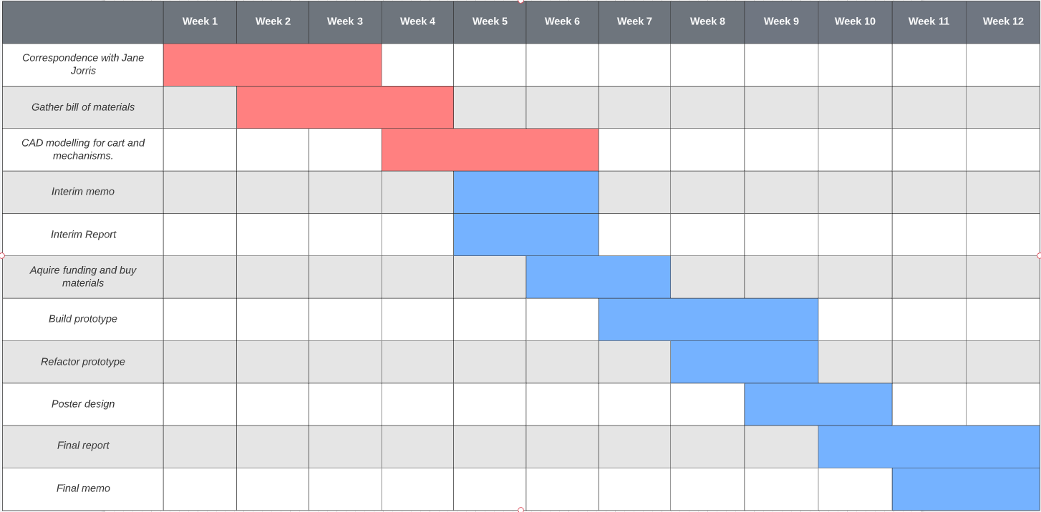

Figure 1: Gantt chart depicting key milestones and timeline for the project.

# 4. Conclusion

The long-term care industry is one of the most vital parts of our society. They are able to care for thousands of elderly Ontarians who require daily care. Currently this industry has been subjected to multiple crises, like COVID-19 and the related nursing shortage, that has put a lot of strain on the nurses who work in this industry. Now more than ever innovative technology is needed to improve the working conditions of these nurses. Our design looks at ways to improve the medicine carts that are frequently used in long-term care facilities. Nurses from the industry have submitted complaints about the current cart design and suggested way they can be improved. With these suggestions we were able to produce several design alternatives that can improve the medicine carts. The cart’s handle, digital interface, pill storage and security have all been reexamined and redesigned to improve the nurses’ workflow. In the future we will be producing a prototype of our design and get final approval by practicing long-term care nurses.

## 5. References

[1] C. Perkel, “Covid-19 pandemic 'crashed' Ontario Nursing Home Staffing; operators say 'crisis' has only grown,” *Global News*, 15-Apr-2021. [Online]. Available: <https://globalnews.ca/news/7760346/ontario-long-term-care-homes-covid-19-coronavirus/>. [Accessed: 22-Oct-2021].

[2] Waters, Thomas R. PhD CPE, Introduction to Ergonomics for Healthcare Workers, Rehabilitation Nursing Journal: September 2010 - Volume 35 - Issue 5 - p 185-191

doi: 10.1002/j.2048-7940.2010.tb00046.x

[3] Asad, Nazia, THEFT OF MEDICINES IN HEALTH CARE ORGANIZATION, 201, 10.13140/RG.2.2.34822.63044.

<https://www.researchgate.net/publication/328382311_THEFT_OF_MEDICINES_IN_HEALTH_CARE_ORGANIZATION>

[4] “View of potential risks associated with medication administration, as identified by simple tools and observations: Canadian Journal of Hospital Pharmacy,” *View of Potential Risks Associated with Medication Administration, as Identified by Simple Tools and Observations | Canadian Journal of Hospital Pharmacy*. [Online]. Available: <https://www.cjhp-online.ca/index.php/cjhp/article/view/1161/1552>.

[5] É. Rochais, S. Atkinson, and J.-F. Bussières, “Nursing perception of the impact of medication carts on patient safety and ergonomics in a teaching health care center,” *Journal of Pharmacy Practice*, vol. 26, no. 2, pp. 131–137, 2012.

[6] A. Argubi-Wollesen, B. Wollesen, M. Leitner, and K. Mattes, “Human body mechanics of pushing and pulling: Analyzing the factors of task-related strain on the musculoskeletal system,” *Safety and Health at Work*, 01-Aug-2016. [Online]. Available: <https://www.sciencedirect.com/science/article/pii/S2093791116300853>.

[7] “Avalo series treatment cart,” *Capsa Healthcare*, 24-Sep-2021. [Online]. Available: <https://www.capsahealthcare.com/product/avalo-treatment-cart/>.

[8] “MG996R servo motor,” *Components101*. [Online]. Available: <https://components101.com/motors/mg996r-servo-motor-datasheet>.

[9] “Esp32 datasheet by Espressif Systems,” *Digi*. [Online]. Available: <https://www.digikey.ca/htmldatasheets/production/2845213/0/0/1/esp32-datasheet.html?utm_adgroup=General&utm_source=google&utm_medium=cpc&utm_campaign=Dynamic+Search_EN&utm_term=&productid=&gclid=CjwKCAjwwsmLBhACEiwANq-tXFRU36IIWE69LA0NNx59ylNWlzvGfwjggnFmSMOQu9UJiuA1Hm5X4RoCPoQQAvD_BwE#pf1c>.

[10] “Duramic 3D PLA plus (PLA+) filament 1.75mm black, 3D printing filament tough PLA plus 1.75mm dimensional accuracy +/- 0.05 mm, 1kg spool : Amazon.ca: Industrial & Scientific,” *DURAMIC 3D PLA Plus (PLA+) Filament 1.75mm Black, 3D Printing Filament Tough PLA Plus 1.75mm Dimensional Accuracy +/- 0.05 mm, 1kg Spool : Amazon.ca: Industrial & Scientific*. [Online]. Available: <https://www.amazon.ca/DURAMIC-3D-Filament-Printing-Dimensional/dp/B07TWDF866/ref=sr_1_7?dchild=1&&keywords=black%2Bpla&qid=1633319951&refinements=p_85%3A5690392011&rnid=5690384011&rps=1&sr=8-7>.

[11] *Princessauto.com*. [Online]. Available: <https://www.princessauto.com/en/3-shelf-steel-service-cart/product/PA0008873218>.

[12] J. B. on O. 22, N. W. on O. 21, N. on O. 21, T. B. on O. 21, M. W. on O. 20, R. B. on O. 20, K. on O. 16, S. L. on O. 16, L. A. on O. 16, and L. C. on O. 15, “Value vinyl blackout roller shades: Select blinds canada,” *Select Blinds Canada - Custom Blinds Shipped Free to your door*. [Online]. Available: <https://www.selectblindscanada.ca/roller-shades/value-vinyl-blackout-roller-shades.html>.

[13] “Zone tech 4-pack universal high power door lock actuator - premium quality heavy duty durable high power door lock actuator, power door lock - amazon Canada,” *Zone Tech 4-Pack Universal High Power Door Lock Actuator - Premium Quality Heavy Duty Durable High Power Door Lock Actuator, Power Door Lock - Amazon Canada*. [Online]. Available: <https://www.amazon.ca/Zone-Tech-4-Pack-Universal-Actuator/dp/B01IWMEBSO/ref=pd_sbs_2/130-0007895-9313767?pd_rd_w=wGUth&&pf_rd_p=290bbede-2610-4048-b146-cdc2ccb8f183&pf_rd_r=BBMJ306J6CCB7P66SXF3&pd_rd_r=223ddaad-4f4f-4834-a71f-ce9440847279&pd_rd_wg=7L3Gt&pd_rd_i=B01IWMEBSO&psc=1>.

[14] “Office chair wheels replacement rubber chair casters for hardwood floors and carpet, set of 5, Heavy Duty Office chair ball casters for chairs to replace chair mats - universal fit,” *Amazon.ca: Home*. [Online]. Available: <https://www.amazon.ca/Office-Replacement-casters-Hardwood-Replace/dp/B081DY9PLK/ref=sr_1_5?dchild=1&&keywords=rubber%2Bcastors&qid=1633384776&sr=8-5>.

[15] “VIPMOON MG996R metal gear torque digital servo with arm horn, 4 pack robot servo for FUTABA HITEC SANWA GWS JR RC helicopter car boat robot, Servos & Parts - Amazon Canada,” *VIPMOON MG996R Metal Gear Torque Digital Servo with Arm Horn, 4 Pack Robot Servo for Futaba Hitec Sanwa GWS JR RC Helicopter Car Boat Robot, Servos & Parts - Amazon Canada*. [Online]. Available: <https://www.amazon.ca/VIPMOON-MG996R-Torque-Digital-Helicopter/dp/B07VT5T9JC/ref=sr_1_10?dchild=1&&keywords=servo&qid=1633384889&sr=8-10>.

[16] “20pcs mini metal hinges 16*13mm vintage antique bronze decorative hinges for dollhouse furniture cabinet closet accessories crafts (with screws), hinges - Amazon Canada,” *, Hinges - Amazon Canada*. [Online]. Available: <https://www.amazon.ca/Mini-Metal-Hinges-Decorative-Dollhouse-Furniture-Accessories/dp/B08P49K231/ref=sr_1_6?dchild=1&&keywords=metal%2Bhinge&qid=1633387931&refinements=p_85%3A5690392011&rnid=5690384011&rps=1&sr=8-6>.

[17] “Tattu 22.8V 25c 6s 23000MAH lipo battery with XT90 plug for UAV,” *Covalin Electrical Supply*. [Online]. Available: <https://covalin.ca/products/tattu-22-8v-25c-6s-23000mah-lipo-battery-with-xt90-plug-for-uav>.

[18] “ESP32 development board + 2.4ghz dual-mode WIFI + bluetooth dual cores microcontroller ESP-WROOM-32 + integrated antenna RF AMP filter AP + CP2012 + ultra low power for Arduino,” *Amazon.ca: Electronics*. [Online]. Available: <https://www.amazon.ca/Development-Dual-Mode-Microcontroller-ESP-WROOM-32-Integrated/dp/B08HJYT6YV/ref=asc_df_B08HJYT6YV/?tag=googleshopc0c-20&linkCode=df0&hvadid=459480626555&hvpos=&hvnetw=g&hvrand=7959032009620274223&hvpone=&hvptwo=&hvqmt=&hvdev=c&hvdvcmdl=&hvlocint=&hvlocphy=9001010&hvtargid=pla-1210282977981&psc=1>.

# 6. Appendix

## 6.1 Sensitivity Analysis

### 6.1.1 - Cart handle sensitivity analysis

Table 13: Sensitivity analysis for cart handle criterion matrix.

|  |  |  |  |  |  |  |  |
| --- | --- | --- | --- | --- | --- | --- | --- |
| Criterion | Weight  (%) |  | Automatically Adjustable Handles | |  | Manually Adjustable Handles | |
|  |  |  | Score | Weighted |  | Score | Weighted |
| Ease of Use | 20 |  | 5 | 1 |  | 3 | 0.6 |
| Reliability | 10 |  | 2 | 0.2 |  | 4 | 0.4 |
| Strength | 40 |  | 3 | 1.2 |  | 4 | 1.6 |
| Cost | 30 |  | 1 | 0.3 |  | 5 | 1.5 |
| Total: |  |  |  | 2.7 |  |  | 4.1 |

### 6.1.2 - Cart security mechanism sensitivity analysis

Table 14: Sensitivity analysis for cart handle criterion matrix.

|  |  |  |  |  |  |  |  |  |  |  |
| --- | --- | --- | --- | --- | --- | --- | --- | --- | --- | --- |
| Criterion | Weight  (%) |  | Pin locks | |  | Magnetic locks | |  | Rolling safety door | |
|  |  |  | Score | Weighted |  | Score | Weighted |  | Score | Weighted |
| Maintenance & Reliability | 25 |  | 4 | 1 |  | 2 | 0.5 |  | 5 | 1.25 |
| Accessibility & Compatibility | 10 |  | 4 | 0.4 |  | 2 | 0.2 |  | 4 | 0.4 |
| Security | 45 |  | 5 | 2.25 |  | 3 | 1.35 |  | 5 | 2.25 |
| Cost | 20 |  | 1 | 0.2 |  | 1 | 0.2 |  | 3 | 0.6 |
| Total: |  |  |  | 3.85 |  |  | 2.25 |  |  | 4.5 |

### 6.1.3 - Cart medication container mechanism sensitivity analysis

Table 15: Sensitivity analysis for cart pill container criterion matrix.

|  |  |  |  |  |  |  |  |  |  |  |
| --- | --- | --- | --- | --- | --- | --- | --- | --- | --- | --- |
| Criterion | Weight  (%) |  | Vertical drawers | |  | Pill by Pill dispensing | |  | Top access compartments. | |
|  |  |  | Score | Weighted |  | Score | Weighted |  | Score | Weighted |
| Maintenance & Reliability | 20 |  | 4 | 0.8 |  | 2 | 0.4 |  | 5 | 1 |
| Accessibility & Compatibility | 25 |  | 2 | 0.5 |  | 4 | 1 |  | 4 | 1 |
| Storage | 50 |  | 3 | 1.5 |  | 5 | 2.5 |  | 5 | 2.5 |
| Cost | 5 |  | 1 | 0.05 |  | 1 | 0.05 |  | 3 | 0.15 |
| Total: |  |  |  | 2.85 |  |  | 3.95 |  |  | 4.65 |

### 6.1.4 - Cart interface application sensitivity analysis

Table 16: Sensitivity analysis for interface criterion matrix.

|  |  |  |  |  |  |  |  |  |  |  |
| --- | --- | --- | --- | --- | --- | --- | --- | --- | --- | --- |
| Criterion | Weight  (%) |  | Touchscreen interfaced with Raspberry Pi | |  | Developing the interface as an app using Android Studio | |  | Creating a Progressive Web application for the interface | |
|  |  |  | Score | Weighted |  | Score | Weighted |  | Score | Weighted |
| Testing & Feedback | 10 |  | 3 | 0.3 |  | 5 | 0.5 |  | 4 | 0.4 |
| Accessibility & Compatibility | 40 |  | 2 | 0.8 |  | 4 | 1.6 |  | 5 | 2 |
| IDE Support | 20 |  | 2 | 0.4 |  | 5 | 1.5 |  | 3 | 0.6 |
| Cost | 30 |  | 5 | 1.5 |  | 2 | 0.6 |  | 2 | 0.6 |
| Total: |  |  |  | 2.9 |  |  | 4.2 |  |  | 3.6 |

## 6.2 Datasheets for electro-mechanical devices

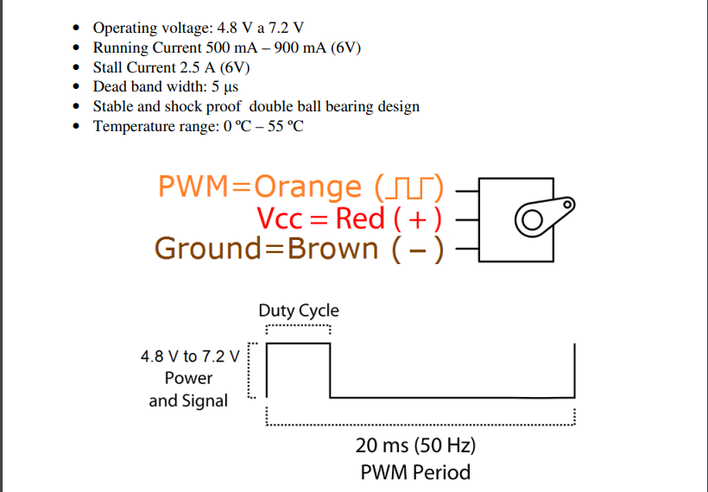

Figure 2: VIPMOON MG996R servo motor datasheet. [8]

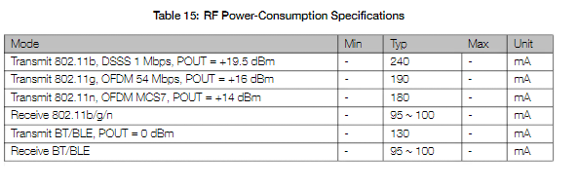

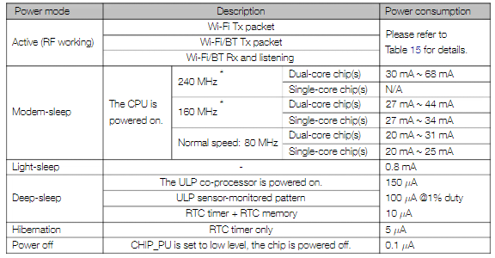

Figure 3: State-based power consumption datasheet of the ESP-32 microcontroller. [9]

## 6.3 Medical Cart Prototype Models

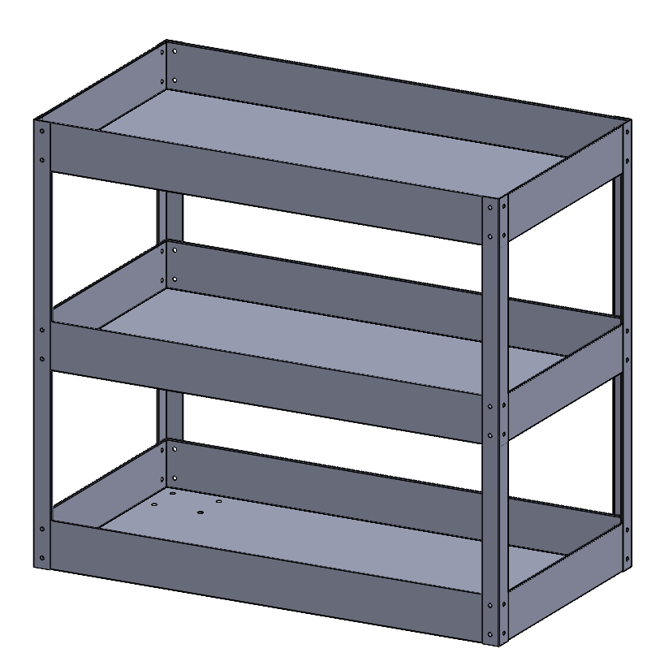Figure 4: Original base cart (before modification).

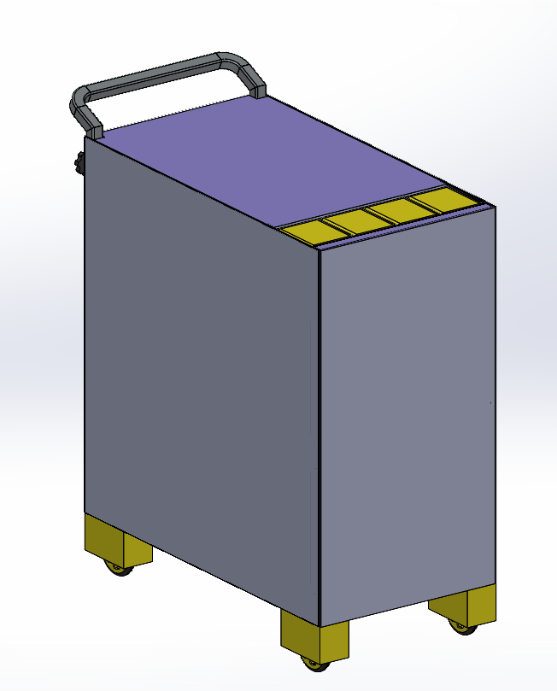Figure 5: Overall medical cart prototype.

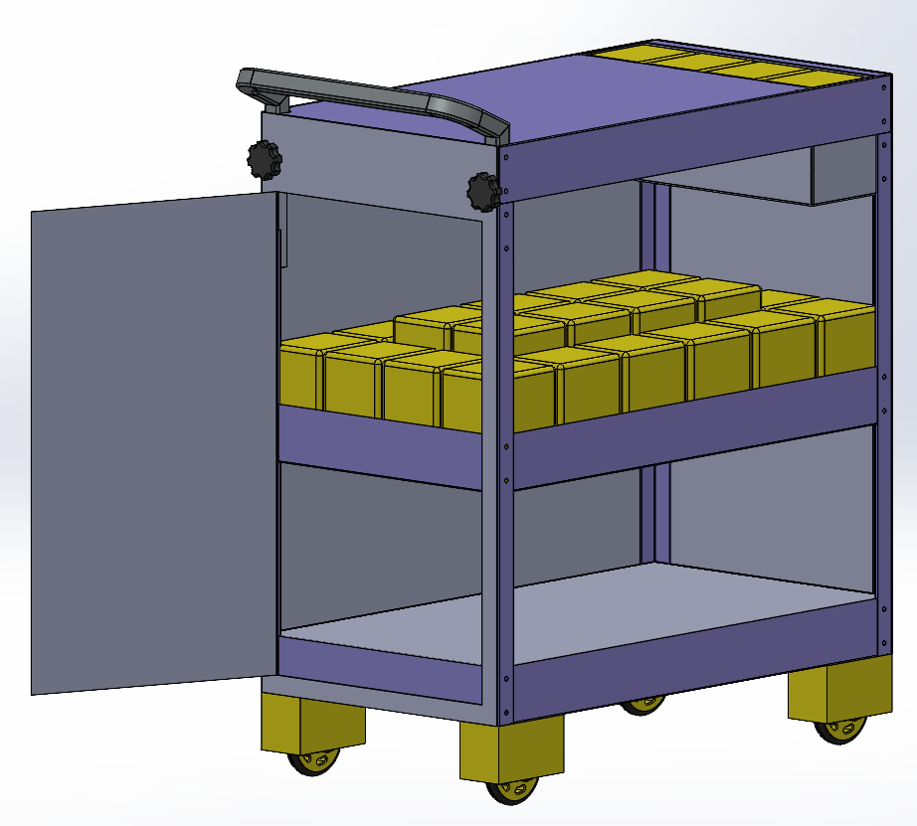Figure 6: Open view of medical cart with additional medical compartment and equipment storage space.

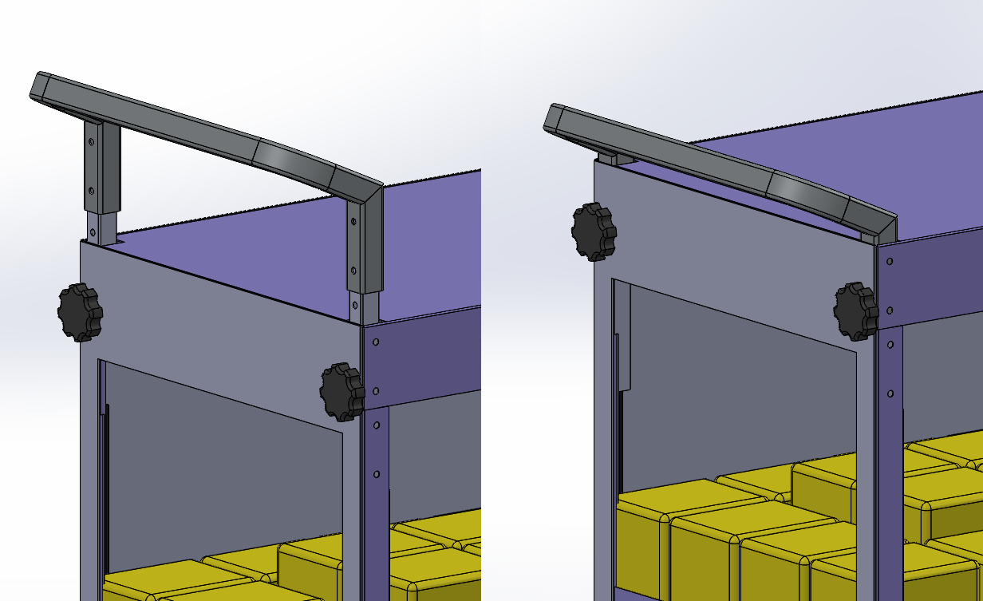Figure 7: Vertical adjustment for cart handle.

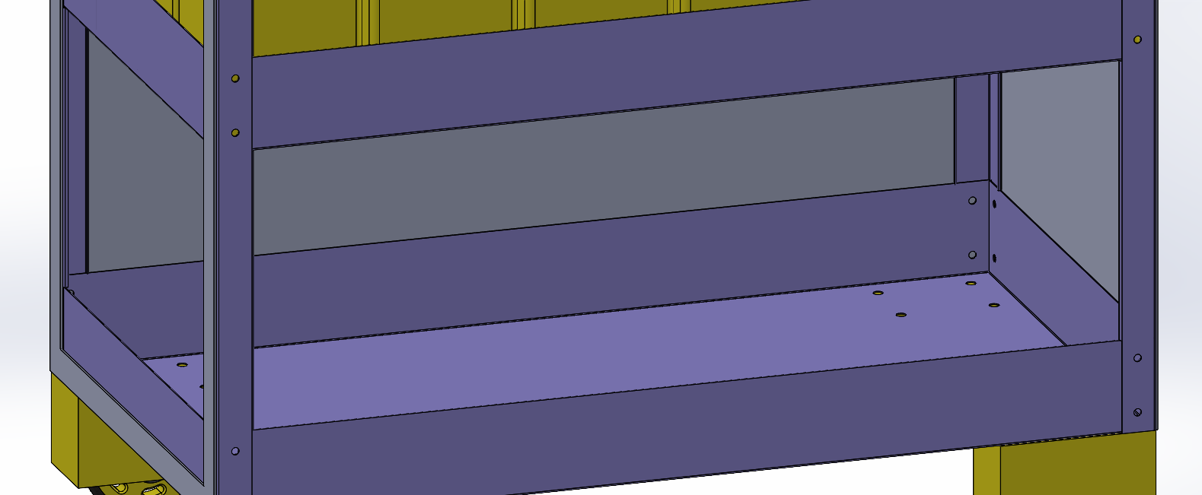Figure 8: Open bottom view for electronics storage.

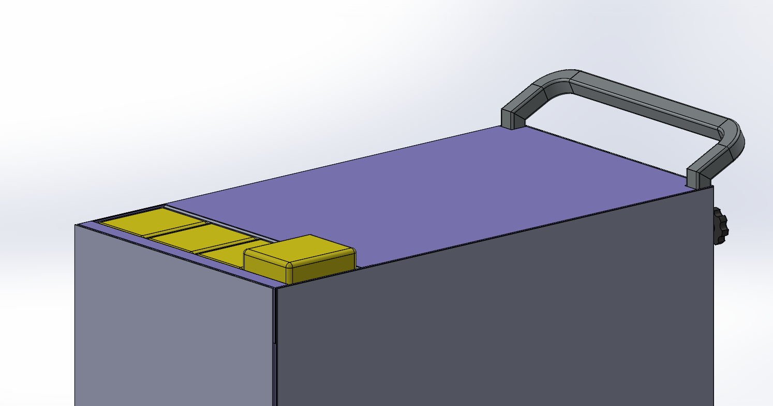Figure 9: Top surface medical compartment extending demonstration.

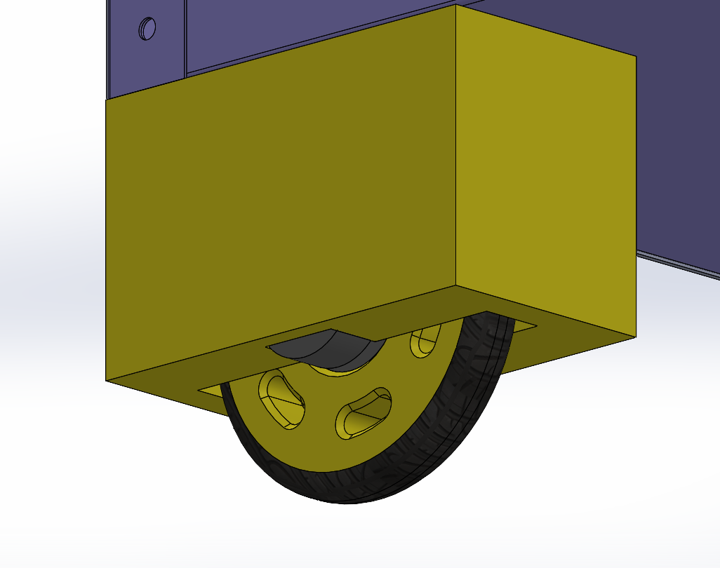Figure 10: Wheel hub with slotted locking wheels

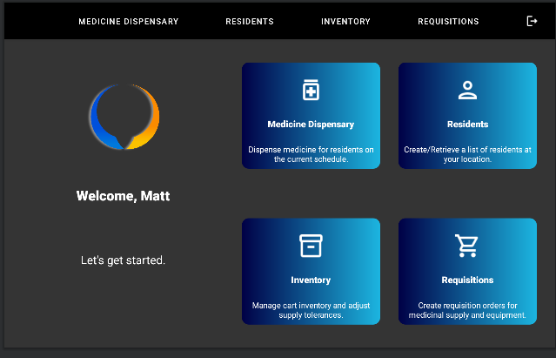

Figure 11: Sample main menu page designed for the interface

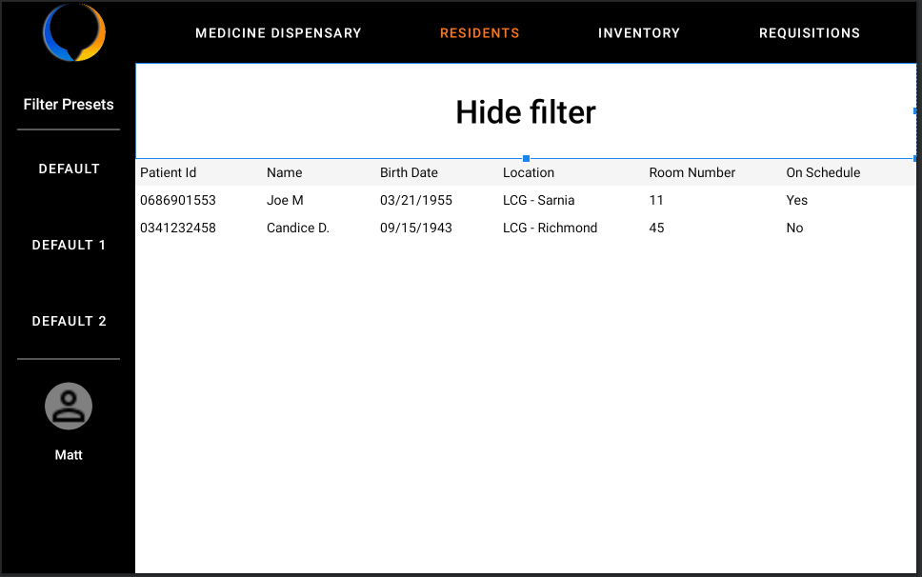

Figure 12: Sample patient information form designed using Android Studio.